TQS: Product specification report

***André Morais [93236], Eduardo Santos [93107], Pedro Bastos [93150], Pedro Santos [93221]***

v2021-06-23

1 Introduction 1

1.1 Overview of the project 1

1.2 Limitations 1

2 Product concept 2

2.1 Vision statement 2

2.2 Personas 2

2.3 Main scenarios 2

2.4 Project epics and priorities 2

3 Domain model 2

4 Architecture notebook 3

4.1 Key requirements and constrains 3

4.2 Architetural view 3

4.3 Deployment architeture 4

5 API for developers 4

6 References and resources 4

# Introduction

## Overview of the project

Our Deliveries Engine is supposed to be a common platform so that any delivery store can use it. Its purpose is to calculate the dynamic matchmaking of orders and riders, manage the riders’ reputation, among other statistics.

T-Tracker is our specific store implementation, that is a delivery service for Covid-19 tests. The idea is to have users request a covid test and receive it in their homes. The T-Tracker will consume the Deliveries Engine API to get the rider’s information of each order.

In the scope of TQS, the project has the objective to implement multiple types of tests, as well as CI/CD pipelines to make sure that a strong SQE practice is used.

## Limitations

One of the unimplemented features is the live tracking with a map in the user’s side. We only have the option to check the status of the delivery, but we would like to have a map with the live location of the rider.

We also intended to have performance tests on our system, and we would definitely implement that with more time.

Also, because we only have HTTP connections in the Virtual Machine, the browser blocks all the connections without HTTPS. Because of that, the maps showing the positions of the rider, costumer and store only shows in localhost.

# Product concept

## Vision statement

(Business Initiative)

This system aims to improve people’s quality of life by providing a platform where they can request a driver to deliver a covid test and, after using the test, its delivery to an analysis laboratory. By using our app, users won’t have to personally travel to the laboratory in order to do quick tests, that way they won’t subject themselves to potentially infected individuals. Users will be able to set their pickup and delivery address (home address), they will also be able to schedule deliveries and rate how the experience was.

(Deliveries Engine)

Riders will be able to register themselves into our system and, at any time, set their status as available or unavailable. Riders will be automatically selected based on their current location and global rating (reputation). This rating will be calculated based on previous job’s ratings made by clients.

Due to it being a platform with the potential to have multiple business partnerships, riders will have the ability to be assigned to jobs from various businesses making it easier for them to get assignments. System administrators will also be able to access statistics such as number of assignments or riders with the best ratings.

## Personas

**Admin:**

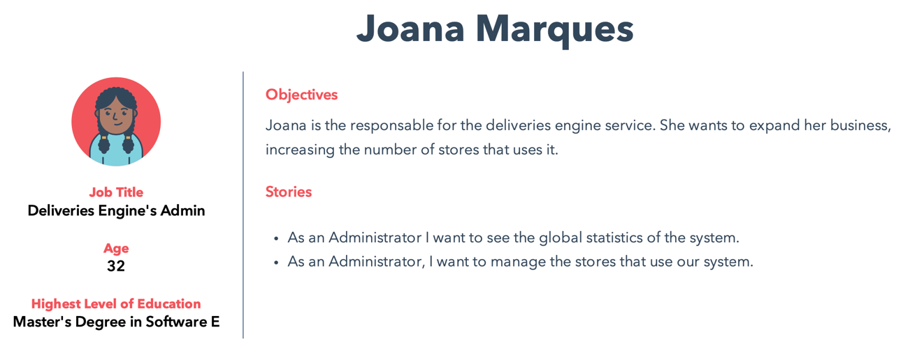

**Rider:**

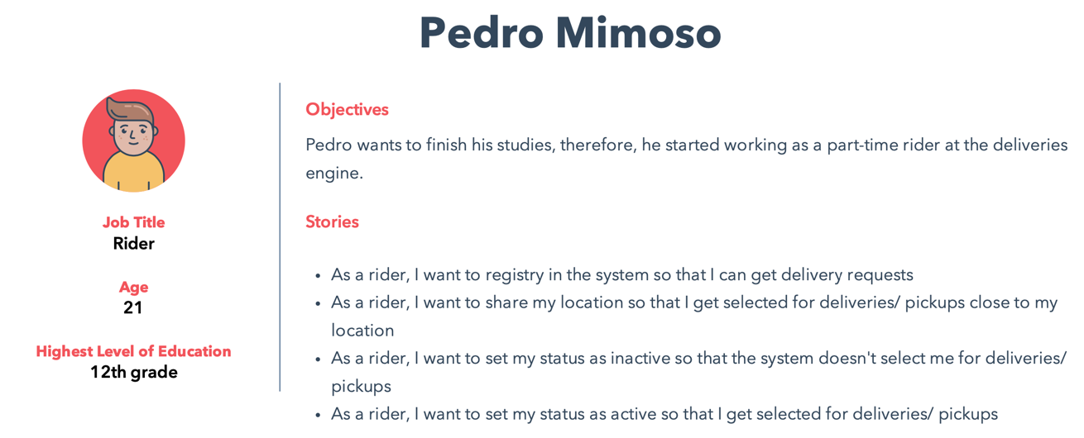

**Owner:**

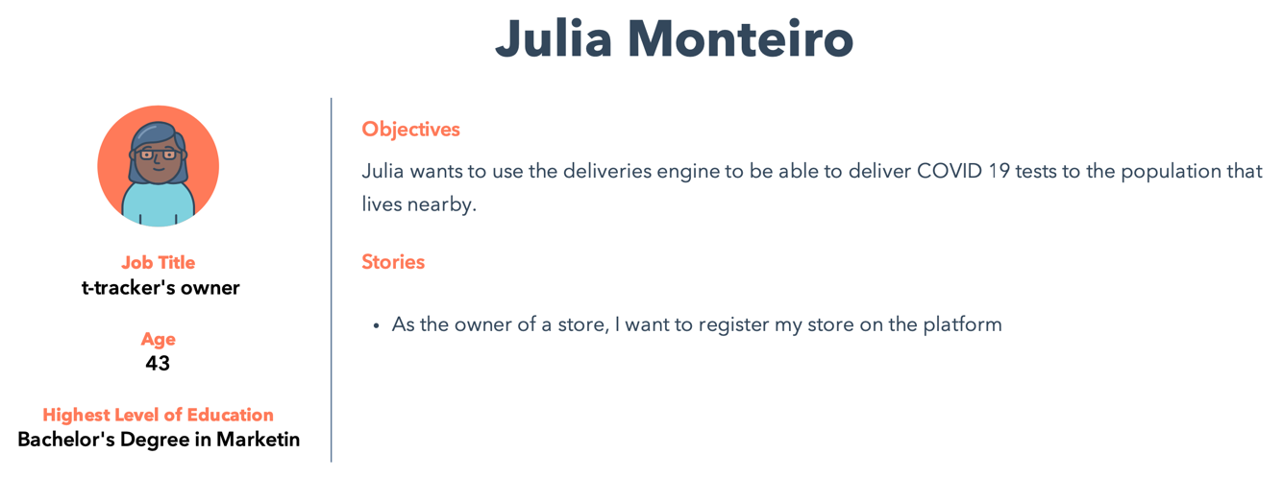

**User:**

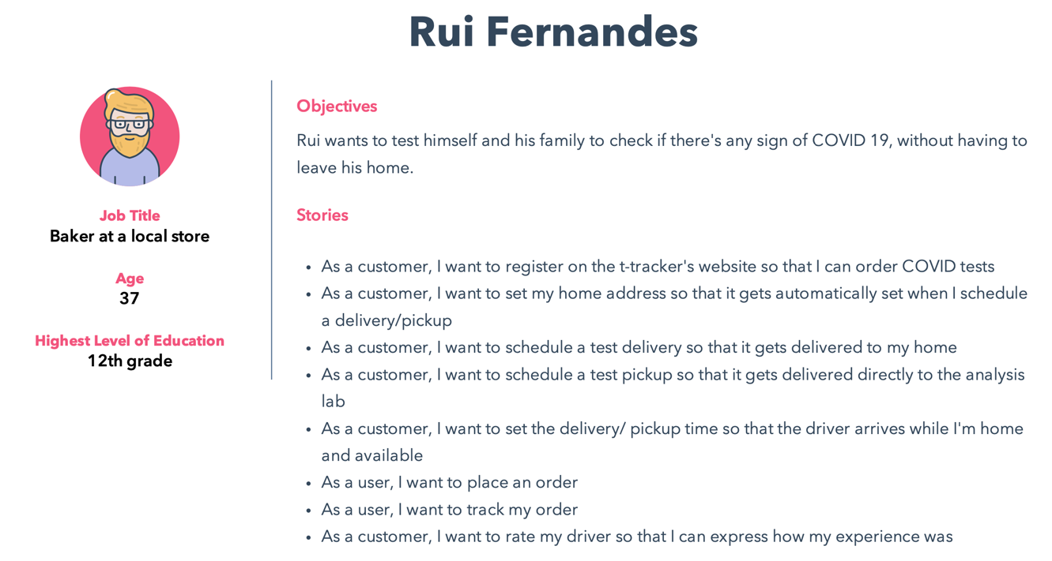

## Main scenarios

These are the main scenarios:

* **Joana Marques checks the global statistics of her system**

Joana, as an **admin**, wants to see the global performance of her system’s riders. She **logs in** and evaluates the global statistics of the system

* **Pedro Mimoso sets his status as active and receives an order request**

**Pedro Mimoso**, as a **rider** for the Deliveries Engine service, has some free time today and wants to make some money. Because he is already registered as a rider in the system, he only needs to set himself as active. He **logs in**, goes to his **profile page** and sets his **status as active**. With this, he is available to be selected to deliver an order. After some minutes, he **receives a request** from the system and **accepts it**. After this, he gets the **store and client’s location** so that he can **pick up the order** on the store and **deliver** it to the client.

* **Julia Monteiro registers her store in the Deliveries Engine service**

**Julia Monteiro**, as an owner of the t-tracker store, wants to i**mprove her store’s capability** and implement a delivery at home system. Yet she can’t afford hiring a software company to produce the system that she wants. Therefore, she wants to find a service that she can use to **manage the pickups** so that she only needs to worry about adapting the store’s website to use it. Thus, she **registers** her store in the Deliveries Engine service so that she can use their services to manage the riders and pickups for her.

* **Rui Fernandes sets his location and places an order**

**Rui Fernandes**, as a general user of the t-tracker application, wants to receive a COVID test at **home** for him and his family so that he doesn’t need to travel to the store. Therefore, he **registers** in the t-tracker application, goes to his **profile**, **sets his location and places the order**. Then, he has a live view of the rider so he can **track** is order.

## Project epics and priorities

|  |  |
| --- | --- |
| Sprint | Epic |
| 1 | * Riders’ registry; * Deliveries Engine’s basic global statistics. |
| 2 | * Each order’s rider being automatically assigned; * User placing an order on t-tracker. |
| 3 | * User placing a pickup order for the COVID tests to the lab; * User being able to track his orders, and rating the riders’ service. |

# Domain model

**Deliveries-Engine:**

Because the full diagram is too long, we had to remove some configuration and repository classes. Basically, the 3 main entities are the Rider, the Store, and the Delivery. We have 2 main controllers, one for the rider’s side and the other for the store’s side. The services implement methods that are called from the controllers.

# Architecture notebook

## Key requirements and constrains

Our system will be developed from scratch. We’ll develop a robust system, that is able to have multiple services (stores) attached to it.

Our goal is to have two main modules: a deliveries engine, that can be used by any external store, and a specific implementation of a store – t-tracker.

Inside each module, we will have a web app, a business logic module, and a database.

We also expect to implement a mobile app, in case we manage to have all the previous requirements implemented on time.

All the communications between the web apps and the business logic will be through HTTP requests to an API.

The communication between each specific store and the deliveries engine will also be through an API.

Each service will be dockerized, and the entire system will be deployed on a virtual machine.

## Diagram Description automatically generatedArchitetural view

Basically, there is one project for each system. In one hand, we have the deliveries-engine application, with spring boot, HTML + CSS + JS and MySQL. This part is intended to manage the riders, i.e., any store can use it to get riders available to deliver their products. It is completely independent from the stores. On the other hand, we also have an application with the same technologies used, called T-Tracker. This application is our implementation of a specific store, a COVID-19 test delivery system. This application will consume the deliveries-engine REST API to get riders for their deliveries.

All the information is consumed through the API, except when a order is placed on the T-Tracker’s side. When this happens, a POST method is sent to the deliveries-engine and then it uses a Web Socket to warn the rider that he as a new delivery to make.

## Diagram Description automatically generatedDeployment architecture

We have two docker-compose files, one for each application. As It was said before, the T-tracker consumes the engine REST API. The client receives his frontend pages through the NGINX and then makes the requests through the REST API.

# API for developers

[Explicar a organização da API. Os detalhes detalhes/documentação dos métodos devem ficar numa solução *hosted* de documentação de APIs, como o [Swagger](https://swagger.io), ou <https://apiary.io/> ]

<what services/resources can a developer obtain from your REST-API?>

<document the support endpoints>

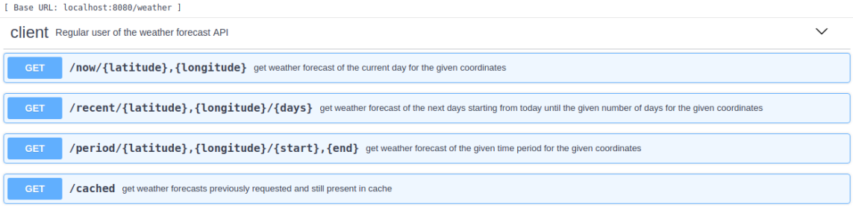

# References and resources

<document the key components (e.g.: libraries, web services) or key references (e.g.: blog post) used that were really helpful and certainly would help other students pursuing a similar work>